QUESTION :- CREATE DATABASE

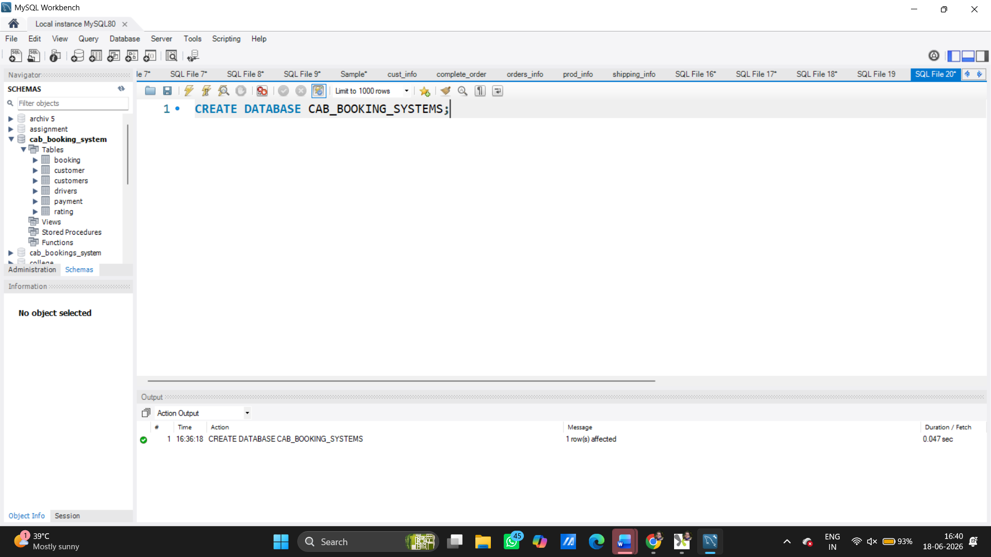

Use database
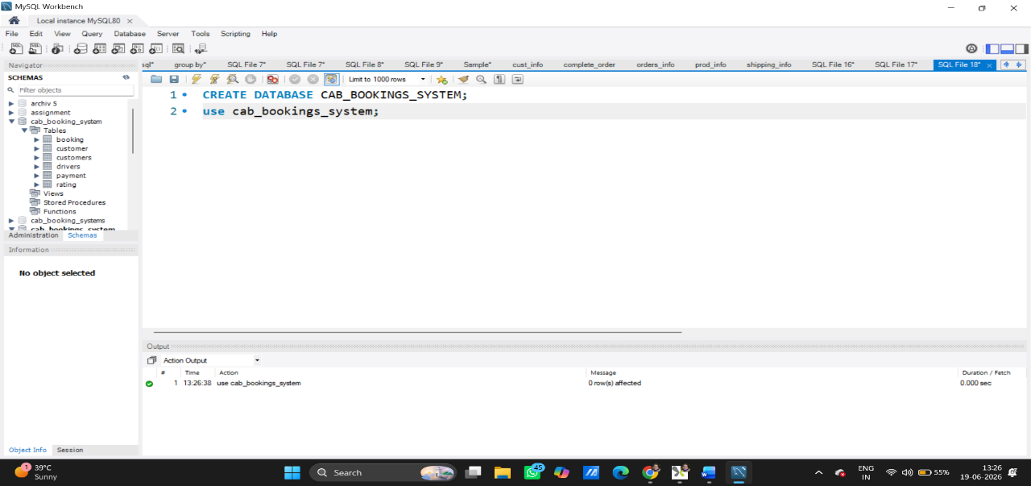

All Customers
SELECT * FROM customer;
The SELECT statement is used to retrieve (fetch) data from one or more tables in a database.
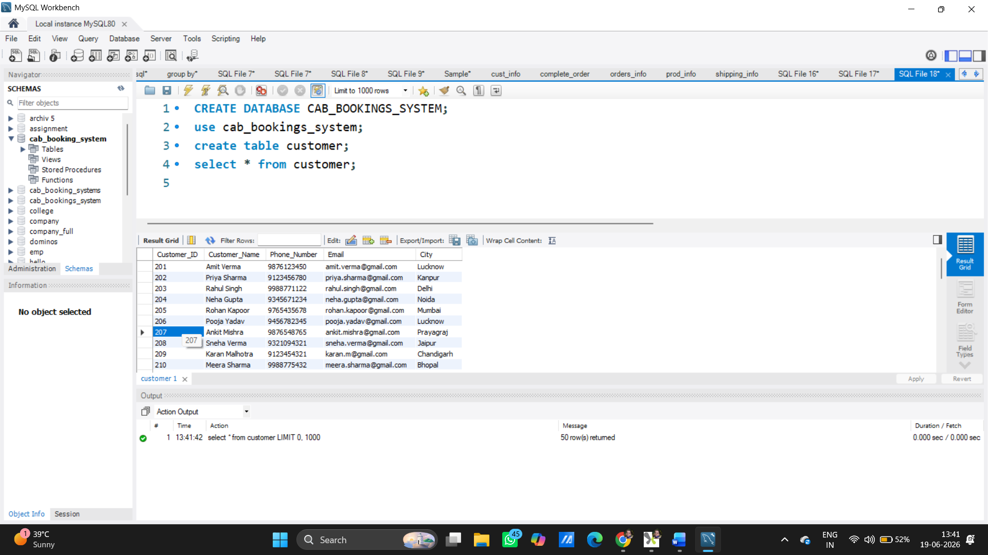

SELECT *
FROM customer
WHERE City = 'Lucknow';
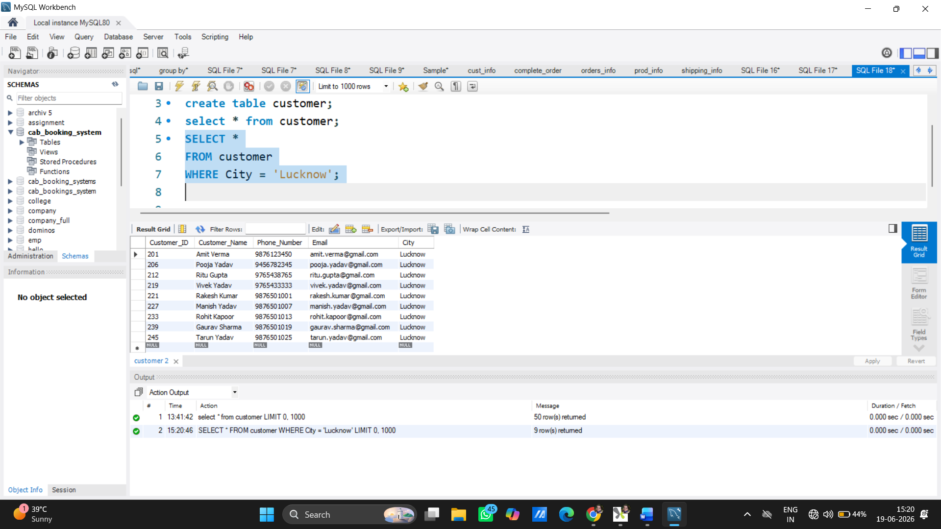

Count Total Customers
SELECT COUNT (*) AS Total Customers
FROM customer;
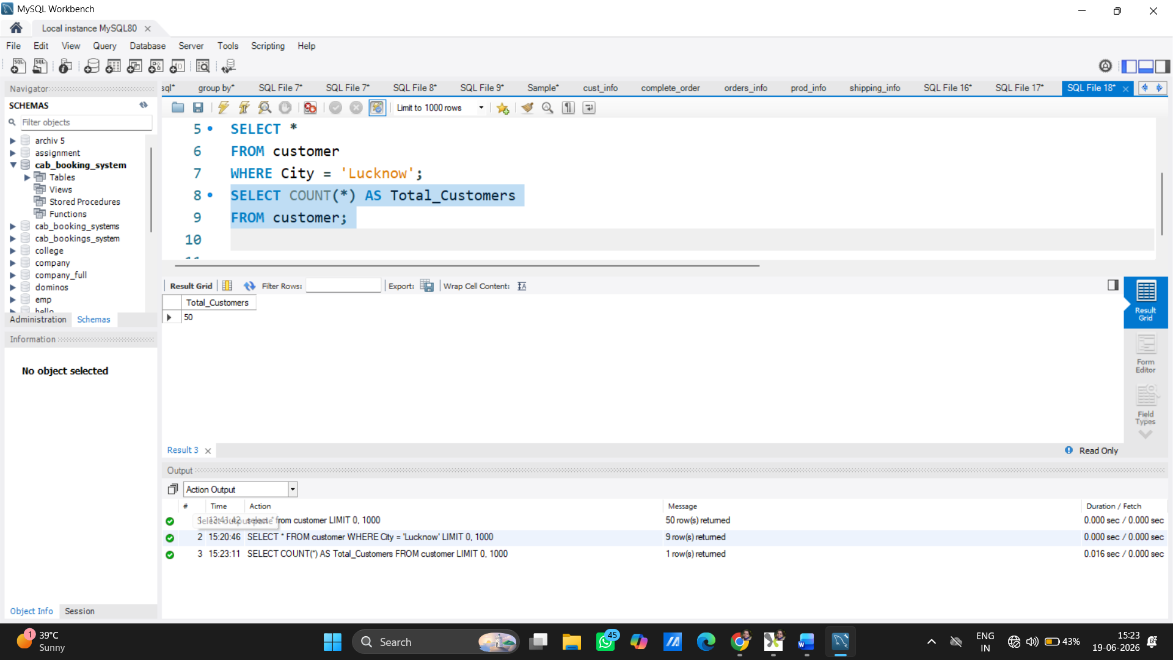

Customer and Booking Details
SELECT c. Customer_ Name,
b. Booking_ID,
b. Fare
FROM customer c
JOIN booking b
ON c. Customer_id = b. Customer_ID;
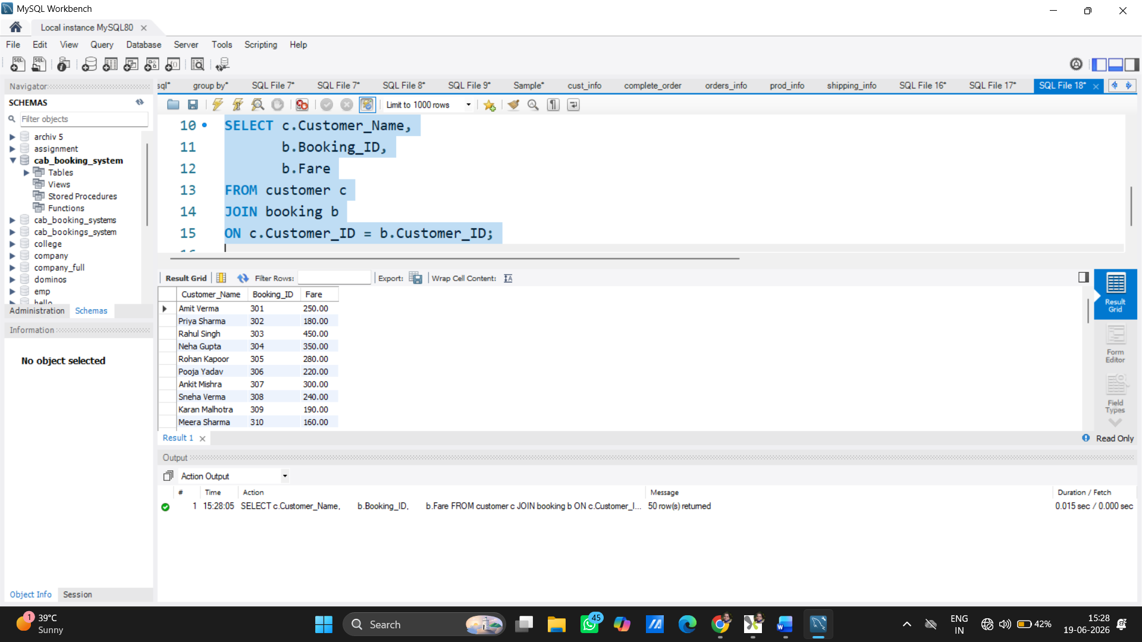

Top 10 Highest Fare Bookings
SELECT *
FROM booking
ORDER BY Fare DESC
LIMIT 10;
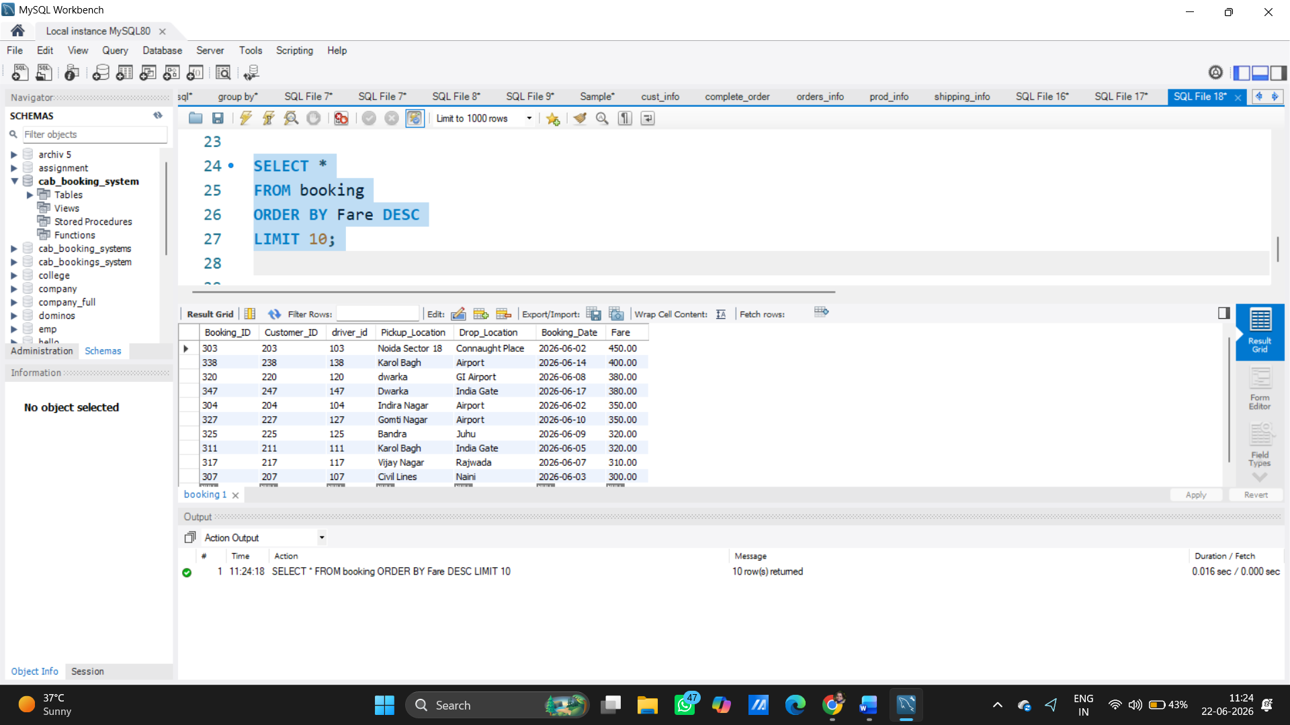

. Average Fare
SELECT AVG(Fare) AS Avg_Fare
FROM booking;
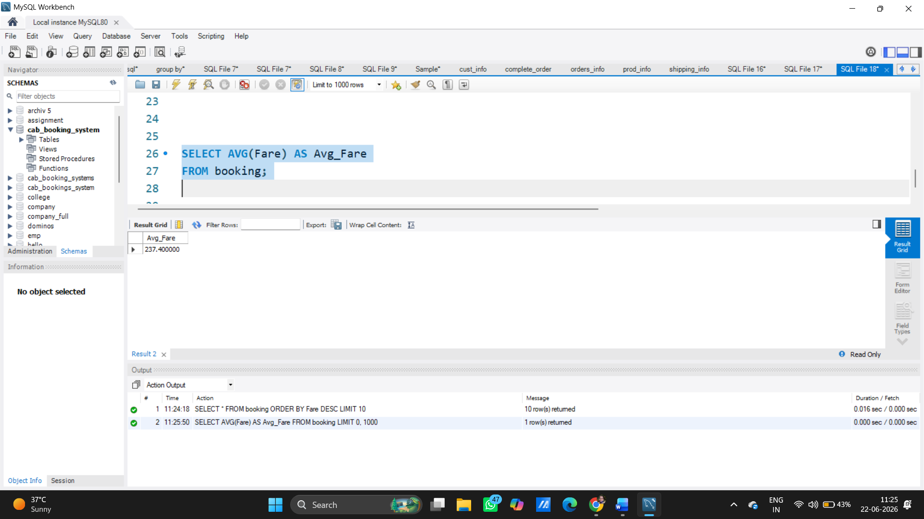

Maximum Fare
SELECT MAX(Fare) AS Highest Fare
FROM booking;
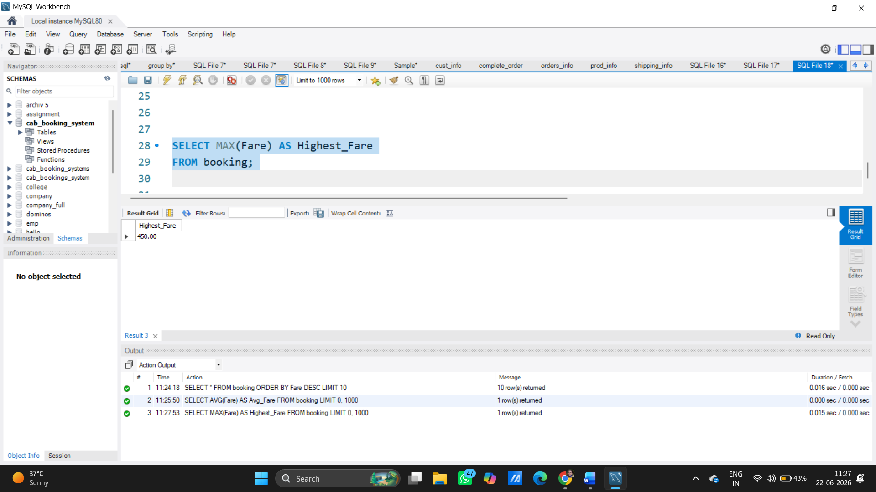

Total Revenue
SELECT SUM(Amount) AS Total Revenue
FROM payment;
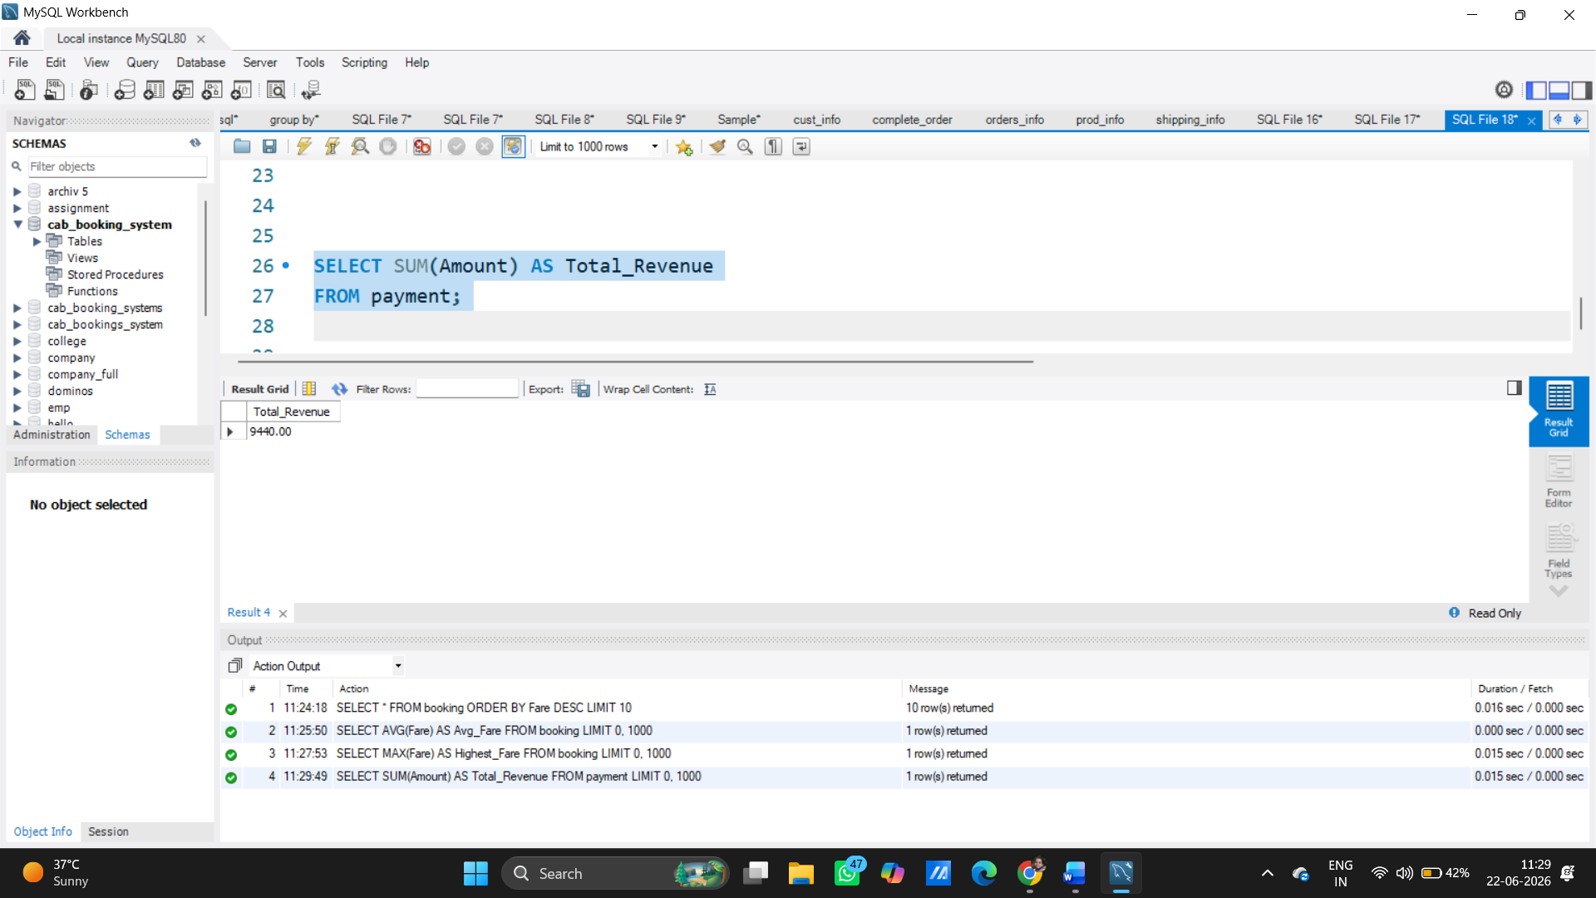
Customer, Driver and Fare
SELECT c. Customer Name,
d. Name AS Driver Name,
b. fare
FROM booking b
JOIN customer c
ON b. Customer_id = c. Customer_ID
JOIN drivers d
ON b. driver_id = d. driver_id;

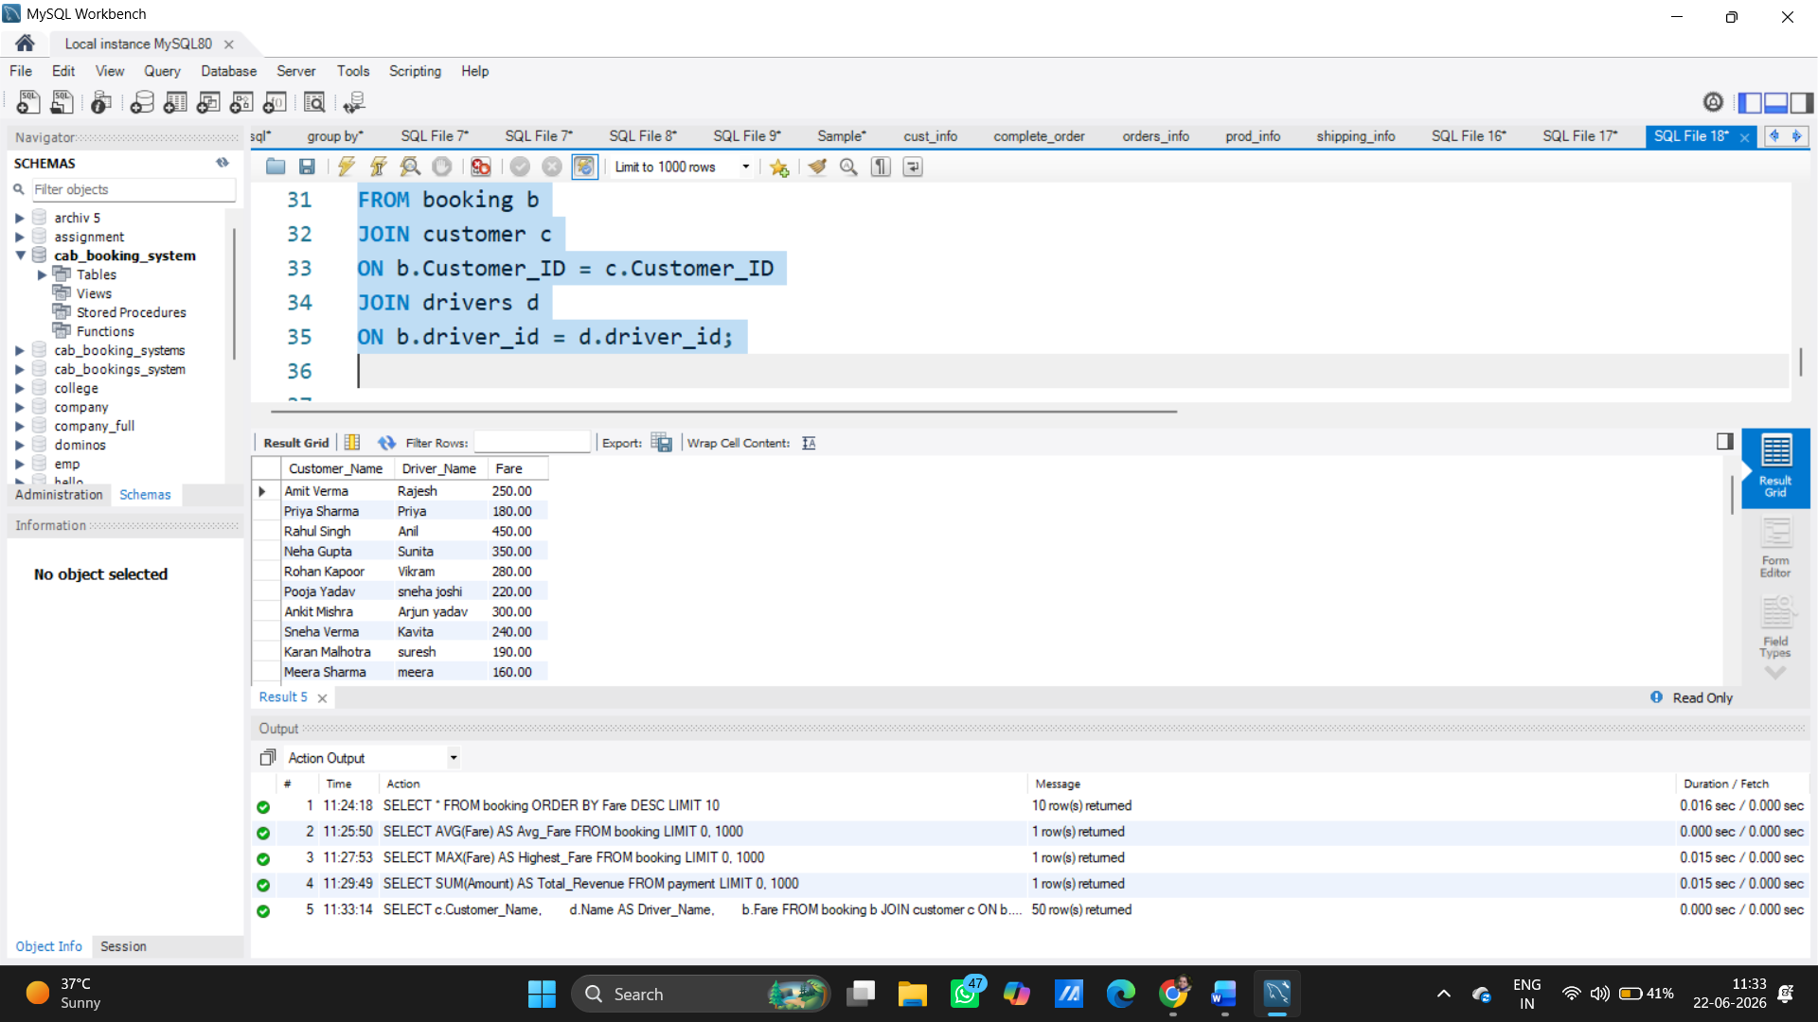

Payment Details with Customer Name
SELECT c. Customer Name,
p. Amount,
p. Payment_Mode
FROM payment p
JOIN booking b
ON p. Booking_ID = b. Booking_ID
JOIN customer c
ON b. Customer_ID = c. Customer_ID;
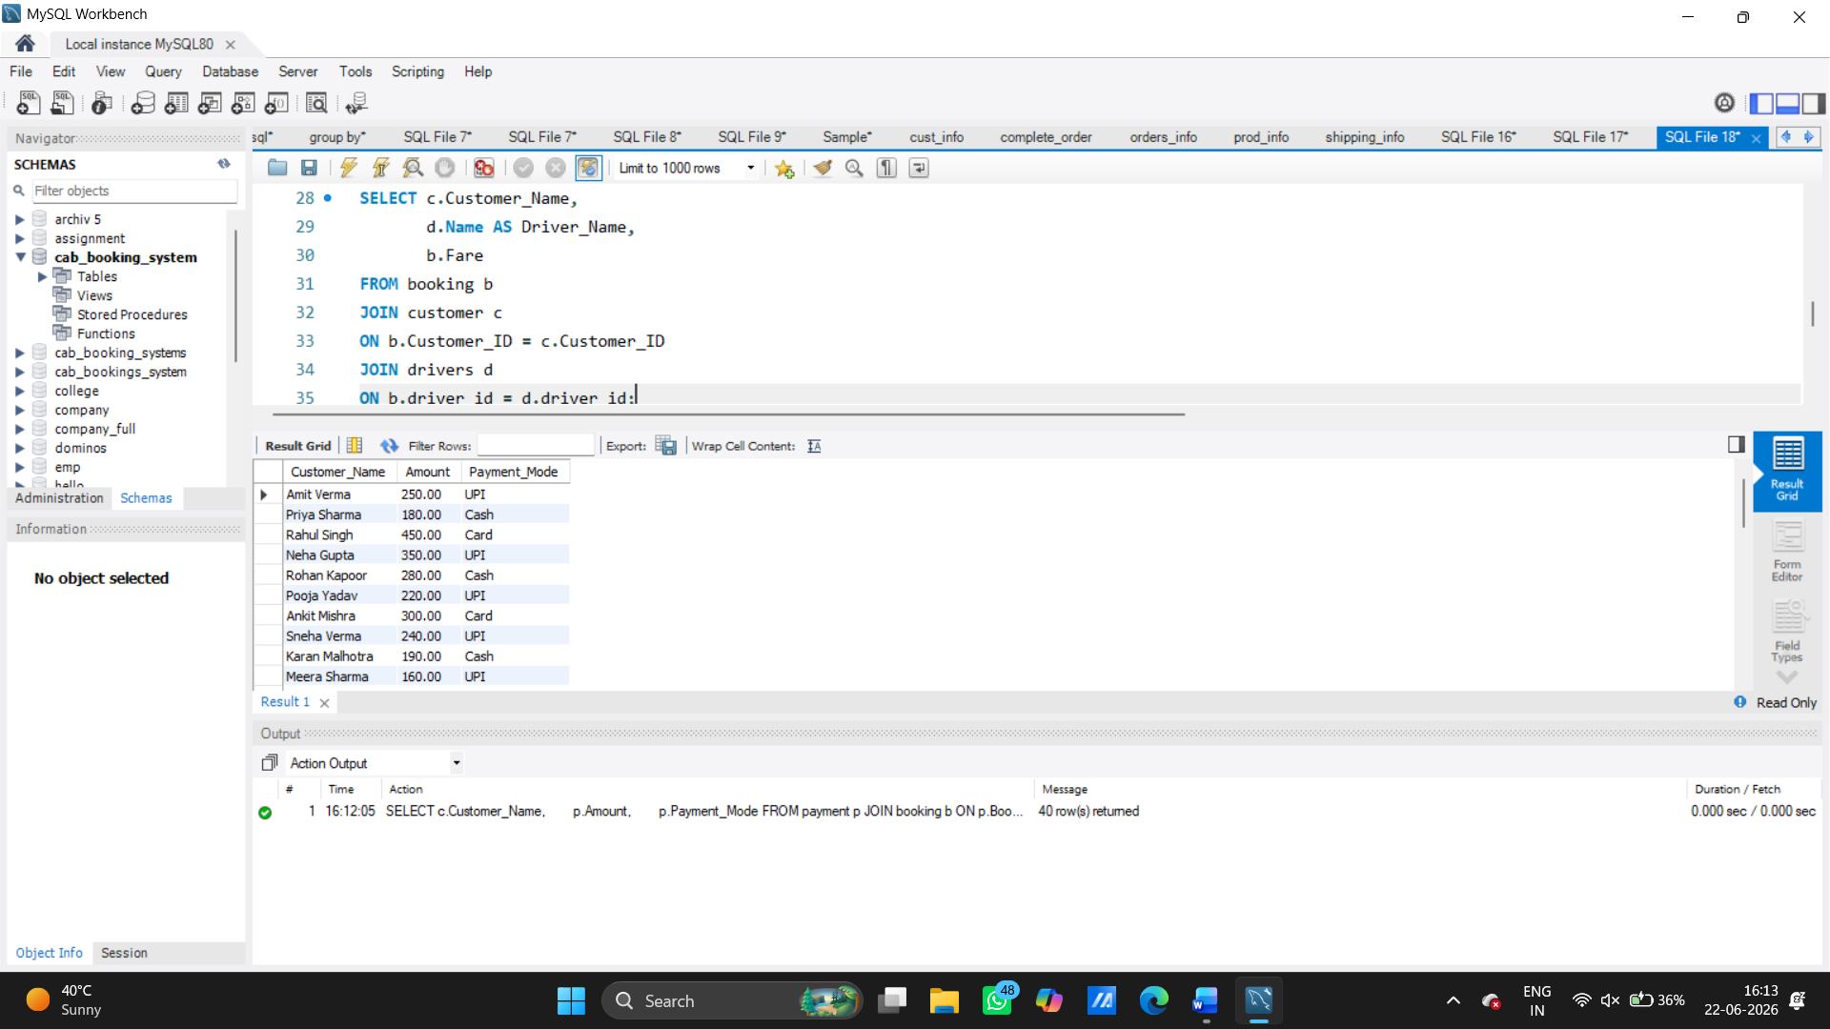

Driver-wise Number of Trips
SELECT driver_id,
COUNT (*) AS Total_Trips
FROM booking
GROUP BY driver_id;
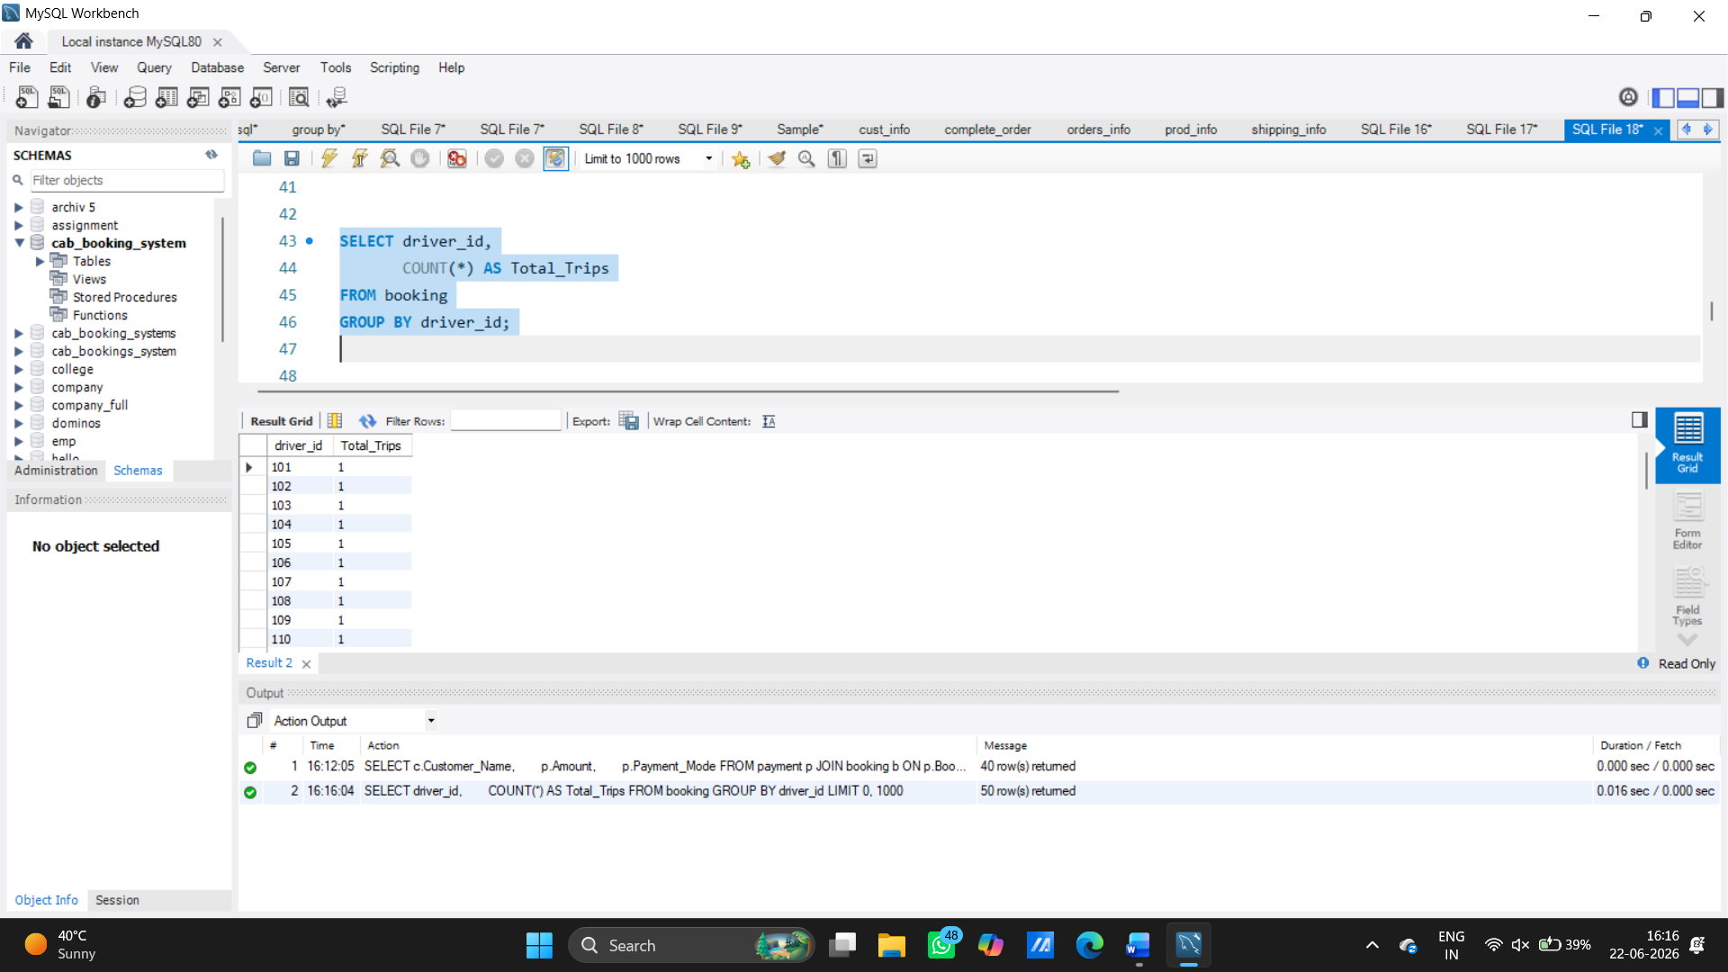

City-wise Customer Count
SELECT City,
COUNT (*) AS Total_Customers
FROM customer
GROUP BY City;
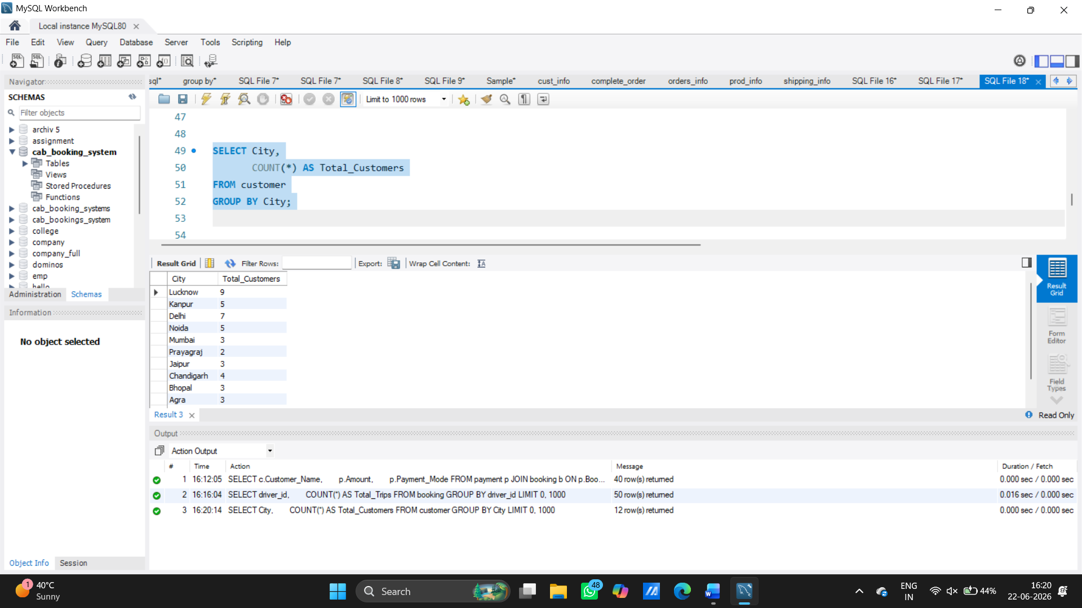

Cities Having More Than 2 Customers
SELECT City,
COUNT (*) AS Customers
FROM customer
GROUP BY City
HAVING COUNT (*) > 2;
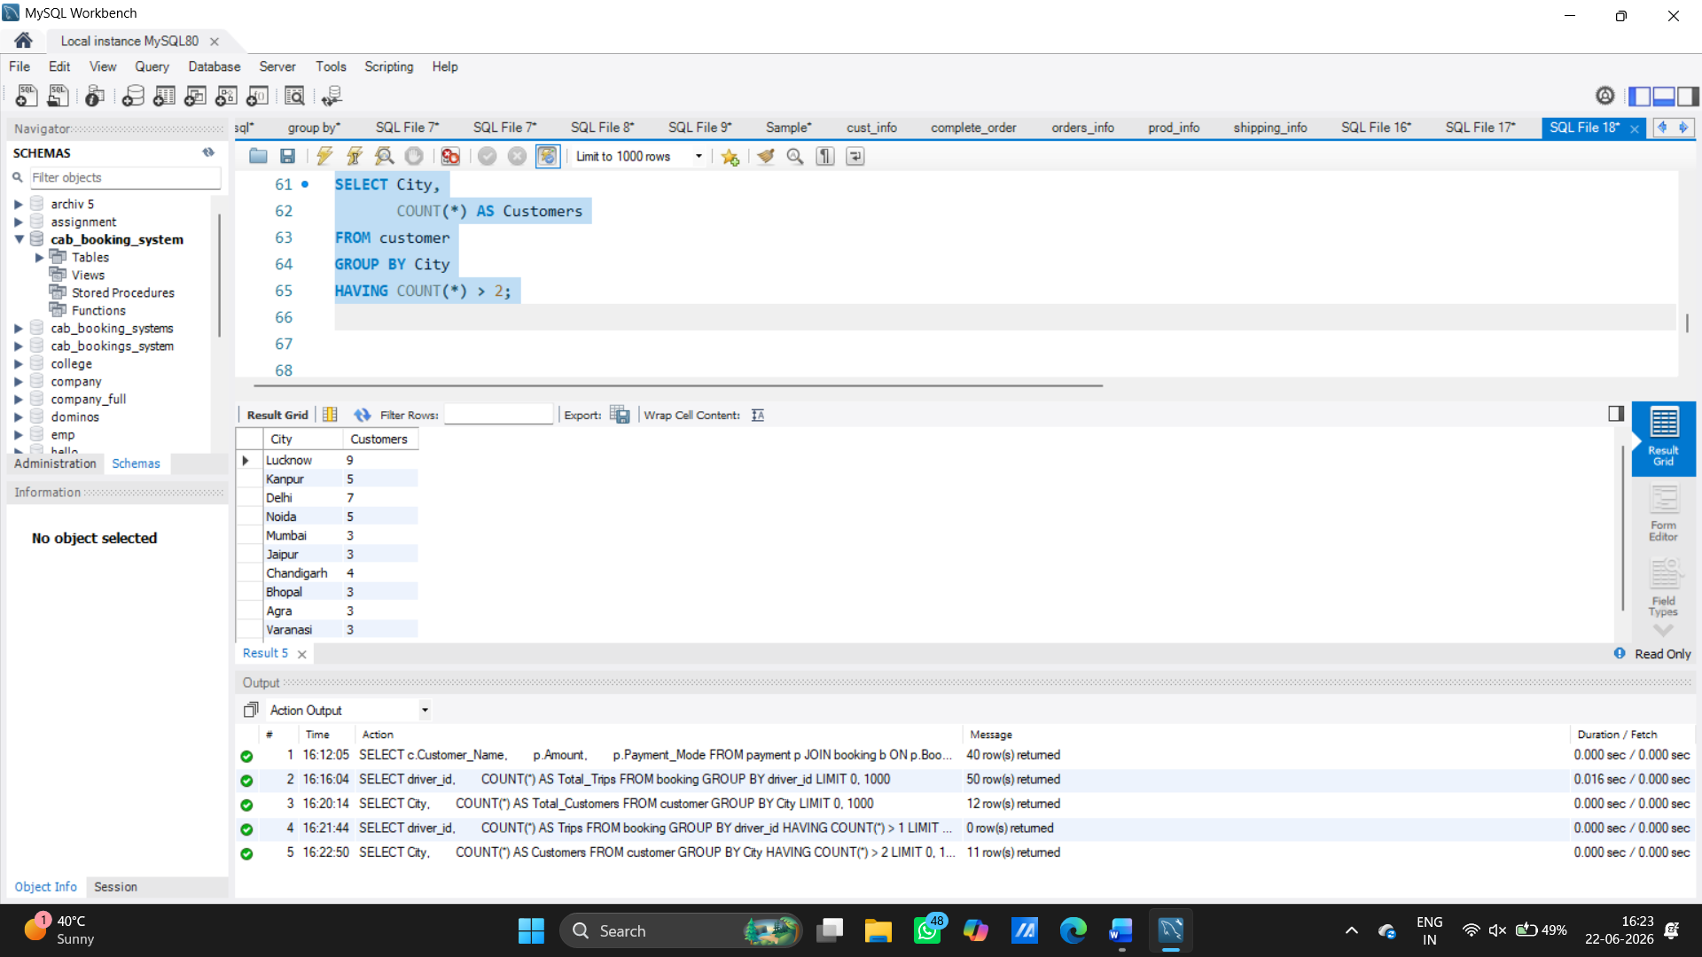

Customers Who Paid Through UPI
SELECT DISTINCT c. Customer_Name
FROM customer c
JOIN booking b
ON c. Customer_ID = b. Customer_ID
JOIN payment p
ON b. Booking_ID = p. Booking_ID
WHERE p. Payment_Mode = 'UPI';

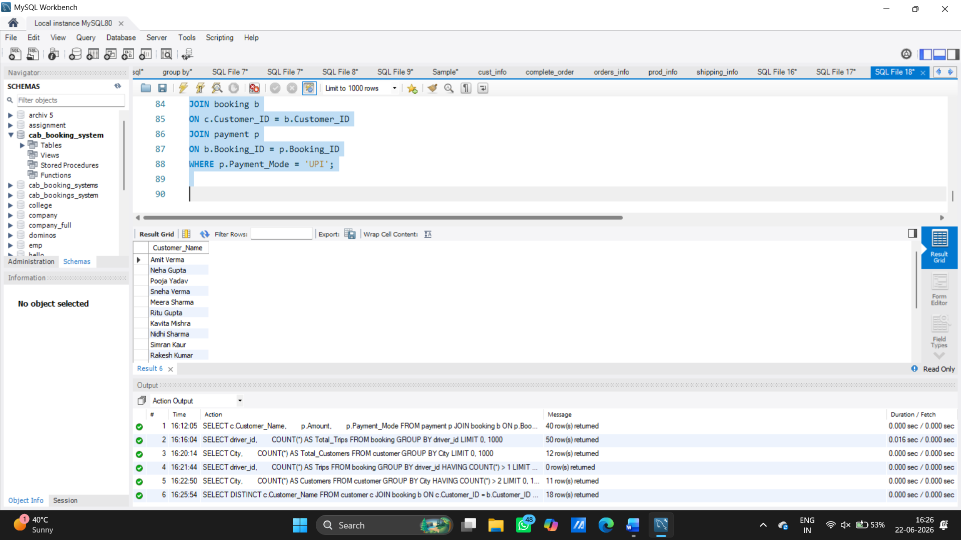

Average Rating
SELECT AVG(Customer_Rating) AS Avg_Rating
FROM rating;
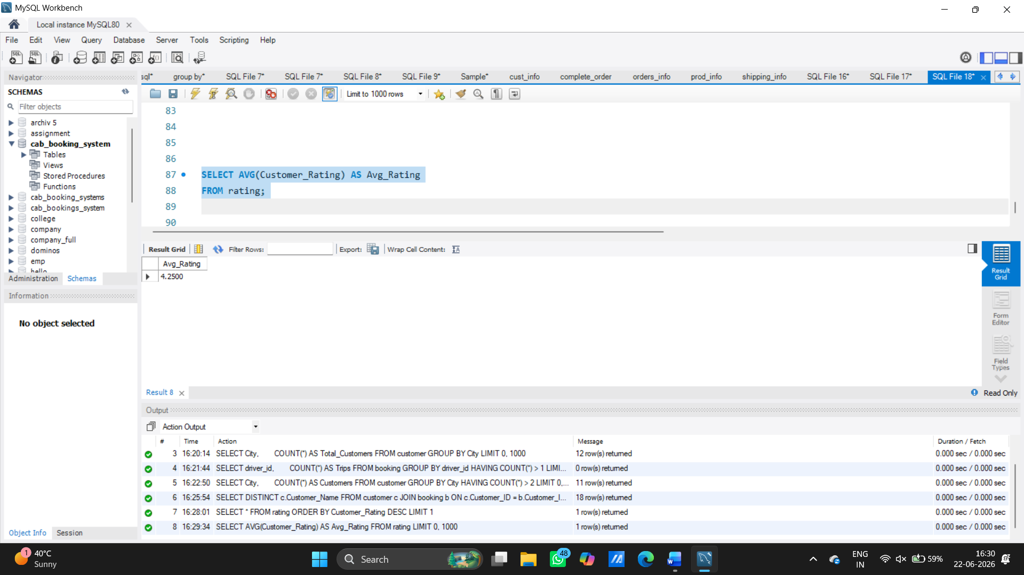

Customer Who Spent the Most
SELECT c. Customer_Name,
SUM (p. Amount) AS Total_Spent
FROM customer c
JOIN booking b
ON c. Customer_ID = b. Customer_ID
JOIN payment p
ON b. Booking_ID = p. Booking_ID
GROUP BY c. Customer_Name
ORDER BY Total_Spent DESC
LIMIT 1;
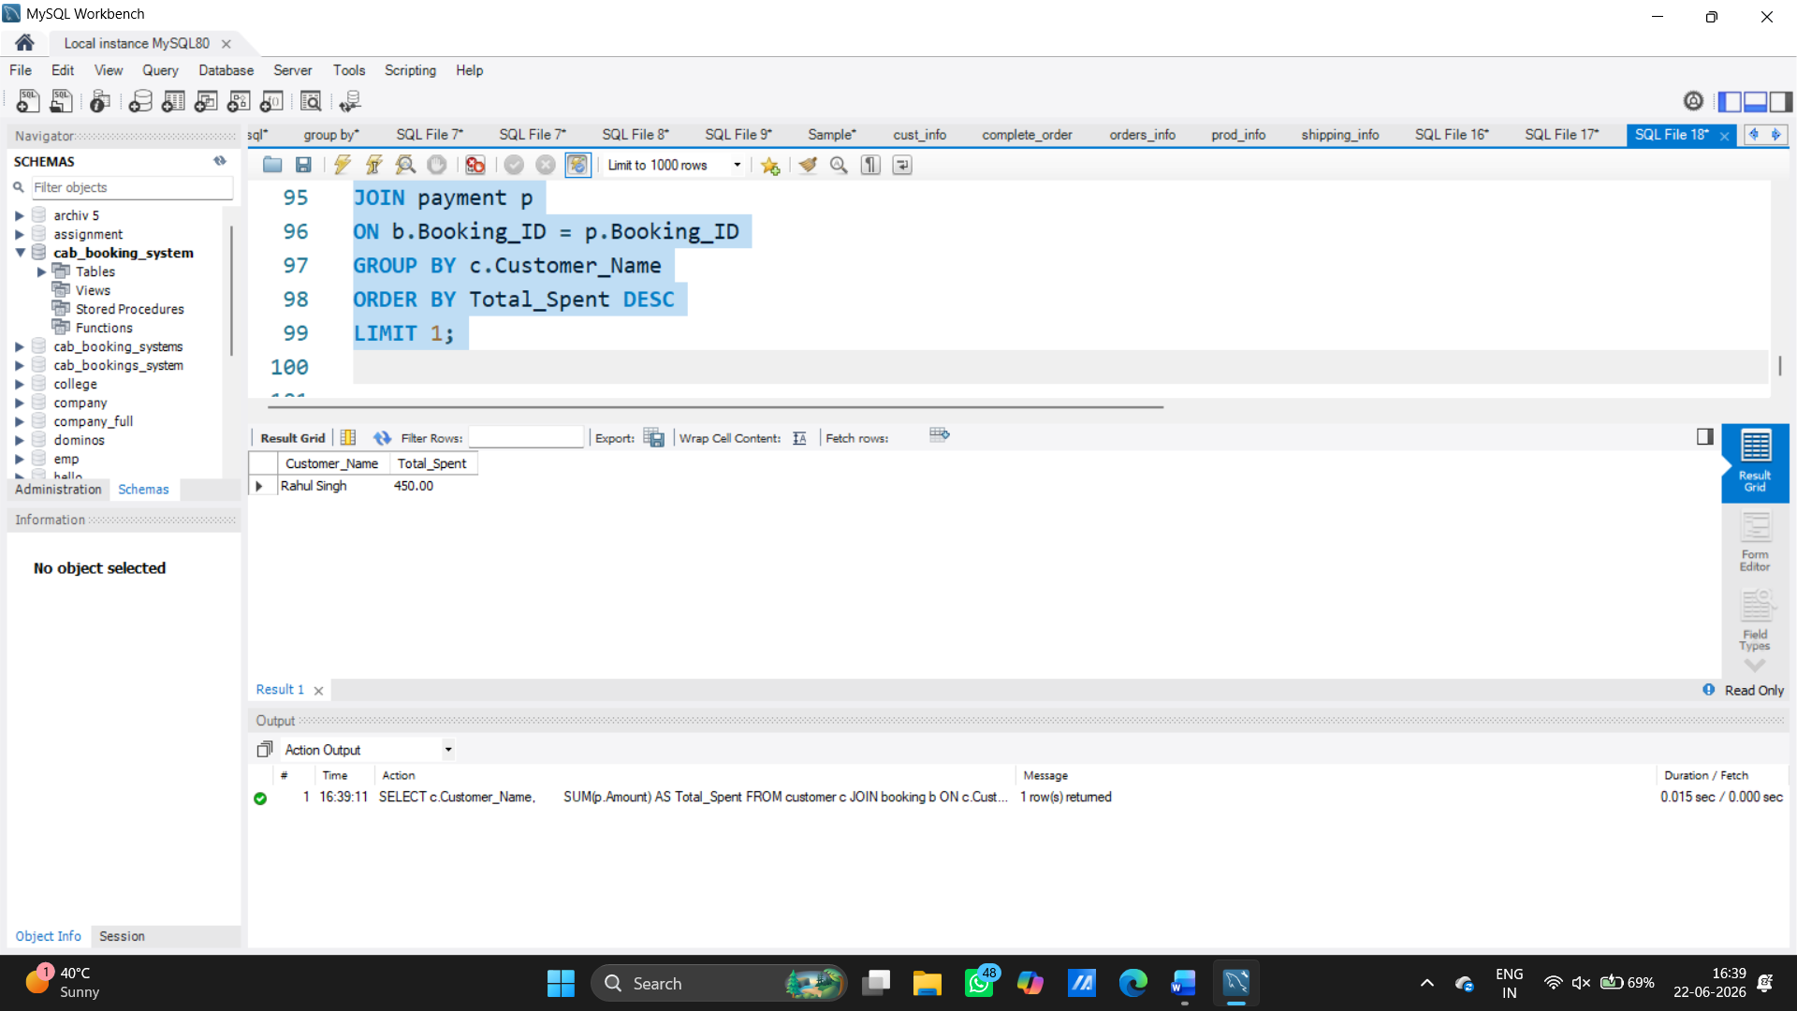

Drivers Who Earned the Most
SELECT d. Name,
SUM (b. Fare) AS Total_Earning
FROM drivers d
JOIN booking b
ON d. driver_id = b. driver_id
GROUP BY d. Name
ORDER BY Total_Earning DESC;
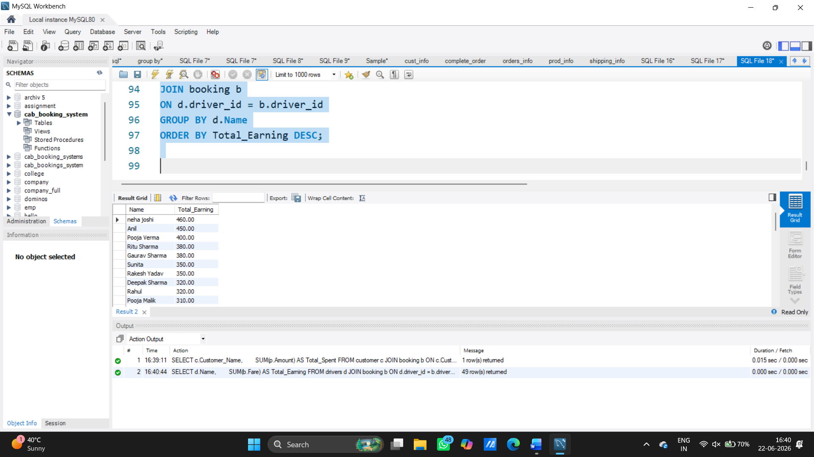

Customers Having Highest Fare Booking
SELECT Customer_Name
FROM customer
WHERE Customer_ID =
(
SELECT Customer_ID
FROM booking
ORDER BY Fare DESC
LIMIT 1
);

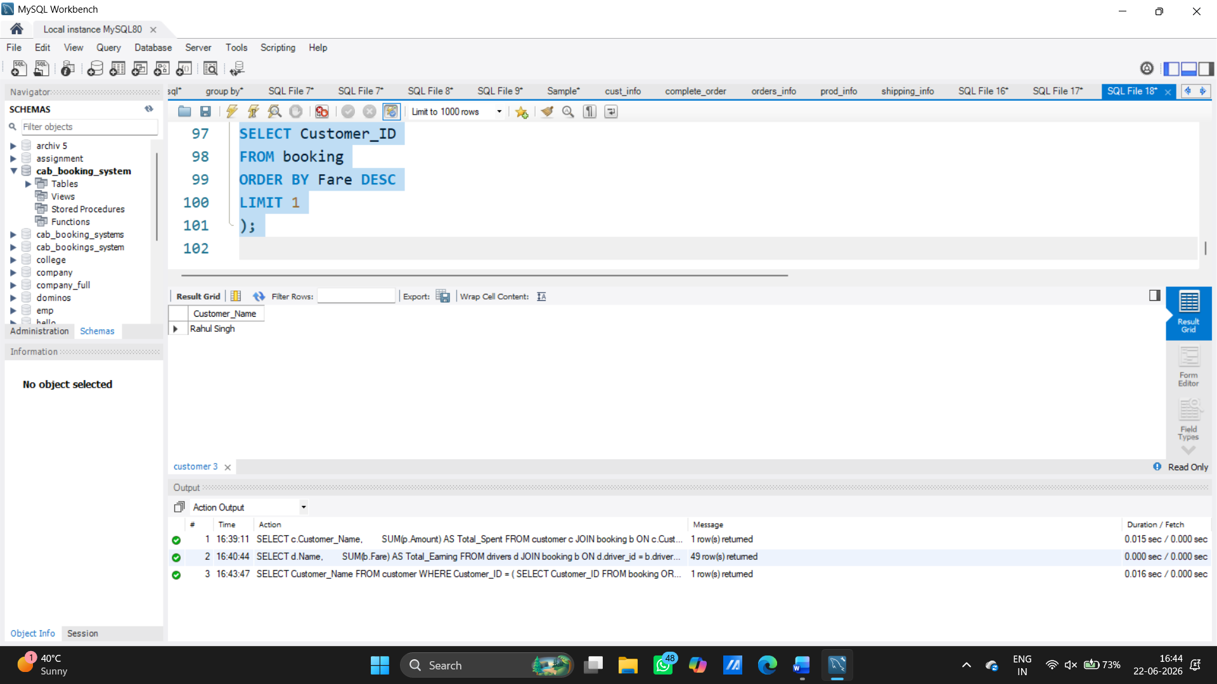

Bookings Above Average Fare
SELECT *
FROM booking
WHERE Fare >
(
SELECT AVG(Fare)
FROM booking
);
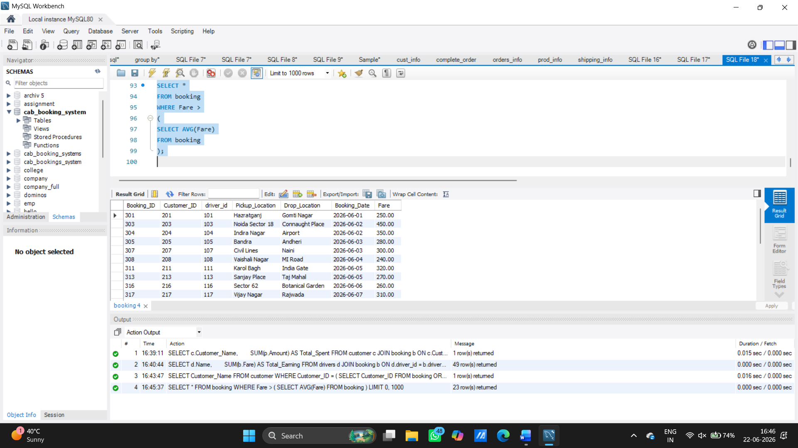
Rank Customers by Spending (Window Function)
SELECT c.Customer_Name,
SUM(p.Amount) AS Total_Spent,
RANK() OVER(ORDER BY SUM(p.Amount) DESC) AS Ranking
FROM customer c
JOIN booking b
ON c.Customer_ID = b.Customer_ID
JOIN payment p
ON b.Booking_ID = p.Booking_ID
GROUP BY c.Customer_Name;
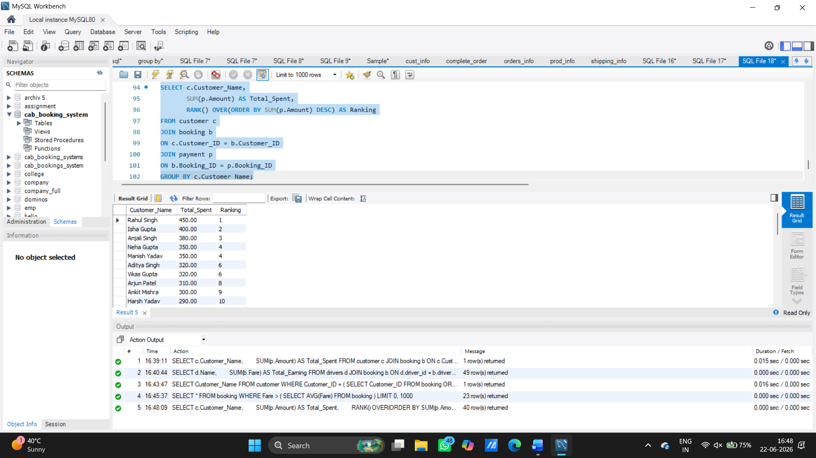
. Row Number for Bookings
SELECT Booking_ID,
Fare,
ROW_NUMBER () OVER (ORDER BY Fare DESC) AS Row_Num
FROM booking;
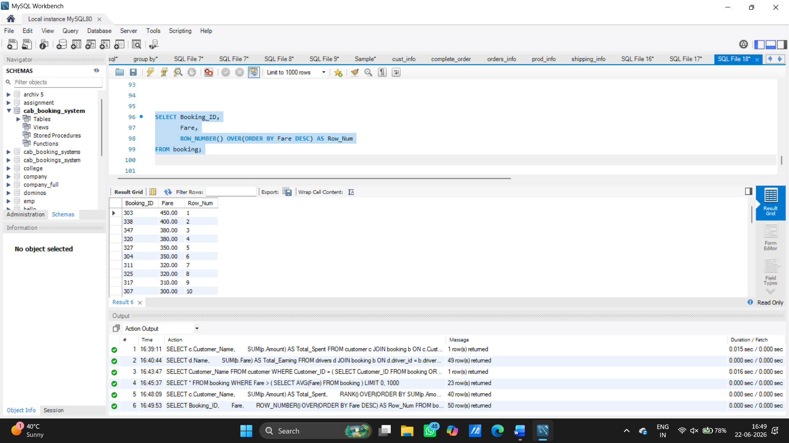

Dense Rank on Fare
SELECT Booking_ID,
Fare,
DENSE_RANK() OVER(ORDER BY Fare DESC) AS Fare_Rank
FROM booking;
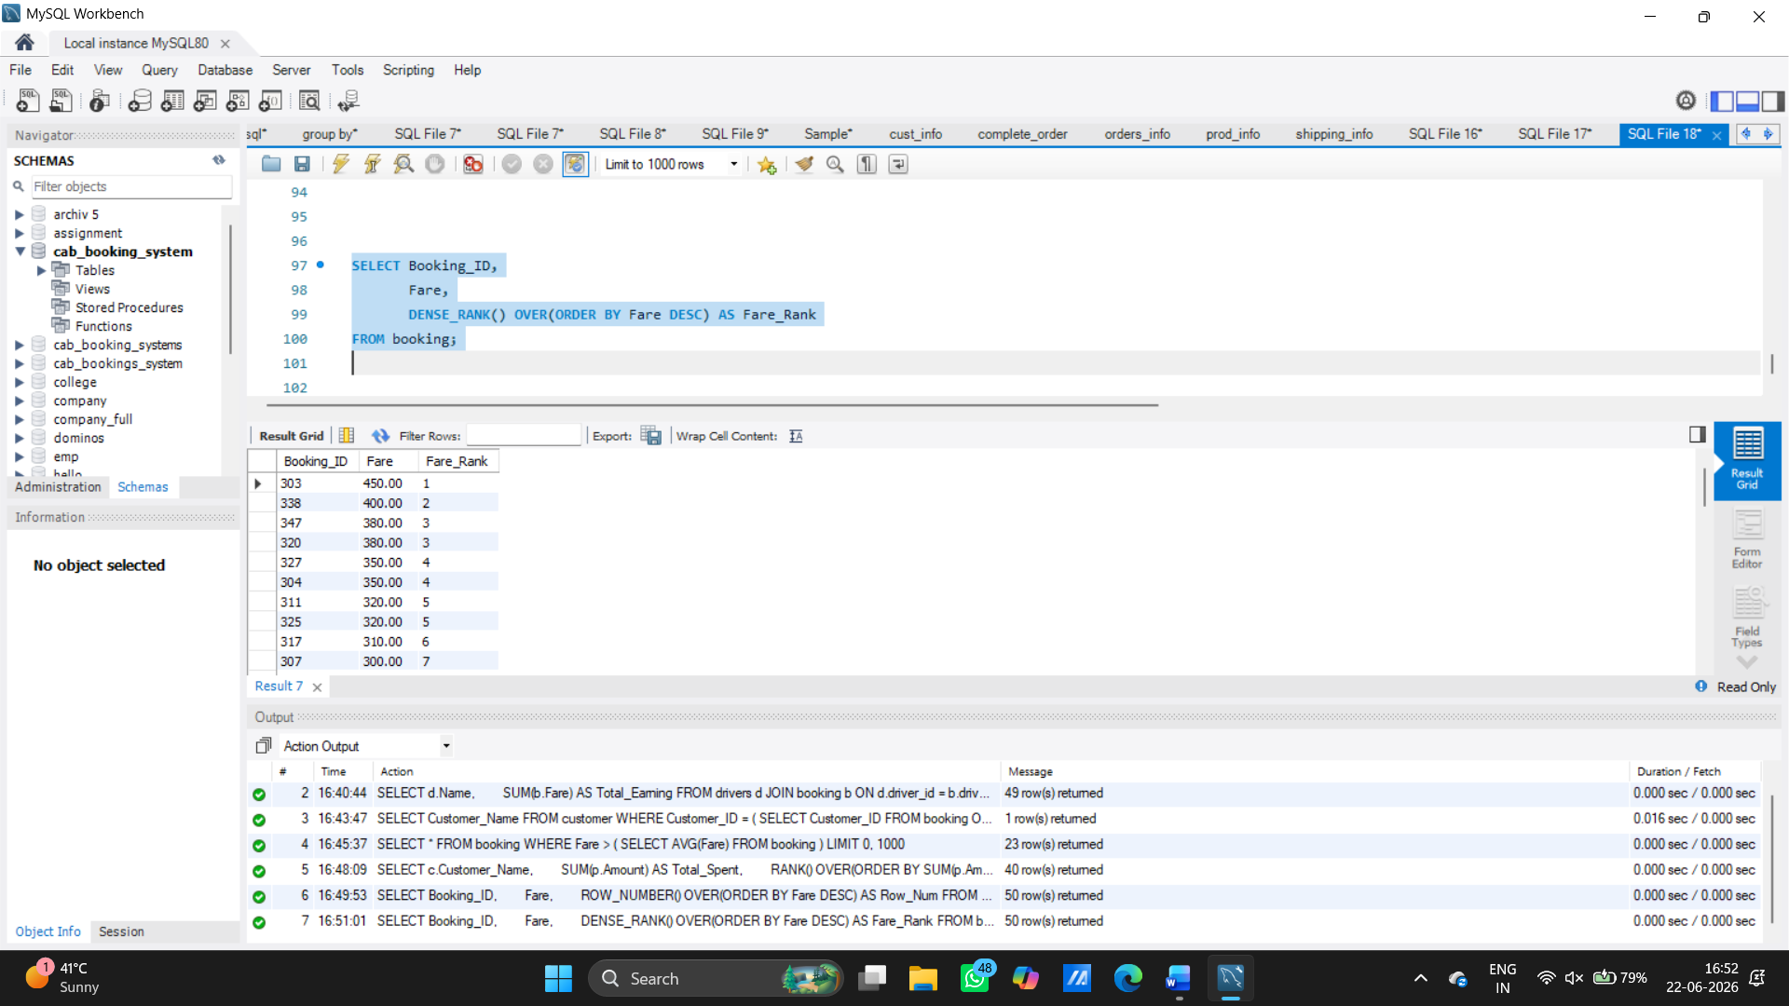

Running Total Revenue
SELECT Payment_ID,
Amount,
SUM(Amount) OVER (ORDER BY Payment_ID) AS Running_Total
FROM payment;
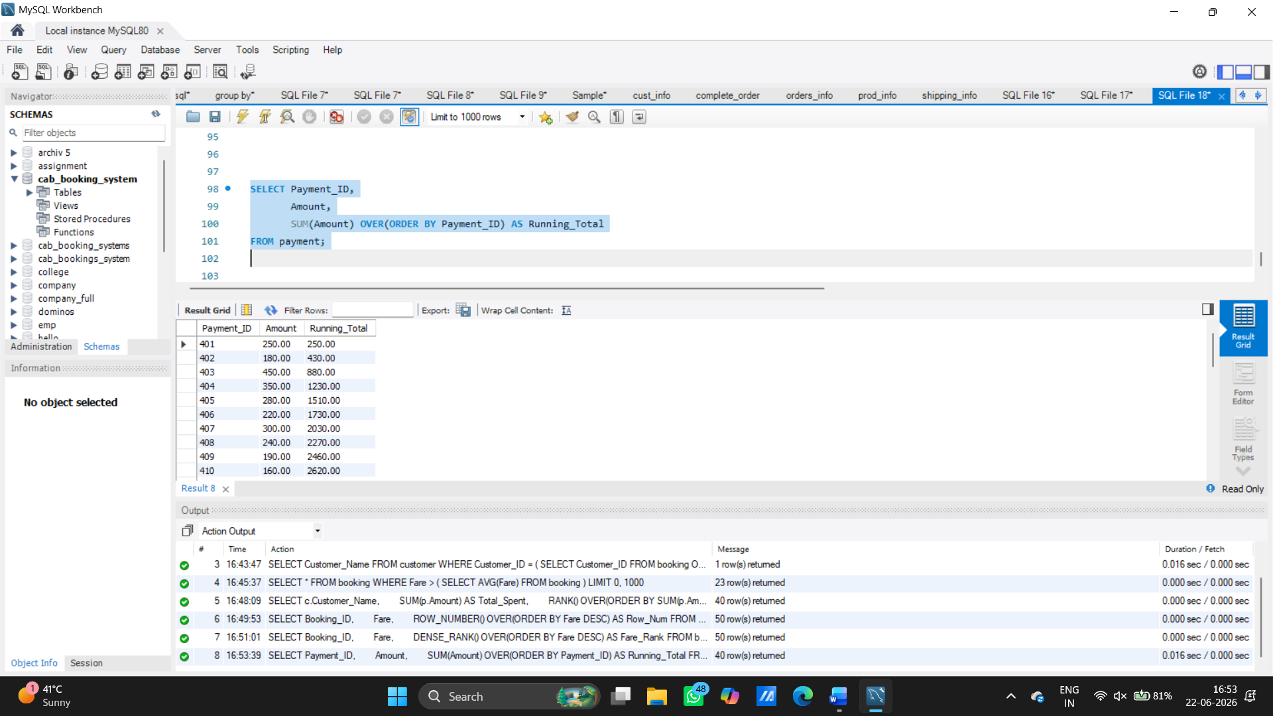

CTE Example – Top Spending Customers
WITH CustomerSpending AS
(
SELECT c.Customer_Name,
SUM(p.Amount) AS Total_Spent
FROM customer c
JOIN booking b
ON c.Customer_ID = b.Customer_ID
JOIN payment p
ON b.Booking_ID = p.Booking_ID
GROUP BY c.Customer_Name
)
SELECT *
FROM CustomerSpending
WHERE Total_Spent > 300;
